Development of Healthcare Management System

(Web Application and Mobile App)

1.0

Technical Document

Revision History

|  |  |  |  |
| --- | --- | --- | --- |
| Date | Version | Description | Author |
| 01.04.2023 | 1.0 | Database Design | Dr S Suhasini  Dr M Suneetha  M Ramesh  Y Kalyan |
|  |  |  |  |
|  |  |  |  |

Table of Contents

1. Introduction 3

1.1. System Overview 3

1.2. Acronyms and Abbreviations 3

2. System Architecture 4

4. Database Specifications 18

4.1. Class Diagram 18

4.2. Sequence Diagram 19

4.3. Data Flow Diagram 19

# Introduction

The Healthcare Management System facilitates patient module for tracking their health, online doctor consultations, booking appointments for lab tests etc. It provides a one stop solution for complete healthcare services starting from booking specialist doctor appointments to medicine reminders.

## System Overview

| System Overview | Details |
| --- | --- |
| System name | HELCOM PLUS |
| System type | Web Application |
| Operational status | In development |
| Database Name | MONGO DB,REDIS Database |

# System Architecture

The PLUS system has been developed as a web application. Client side is written in JavaScript and html5 which are generated using Java Server Page technology. Client part runs in a web browser and communicates with the server side software consisting of a set of Java servlets communicated with the database.

The PLC Database is developed in MS SQL. The PLUS application interfaces with the PLC Database using JDBC connector (Java Database Connectivity) .The figure below shows the architecture of the PLUS Application.

## Database and Application Software Utilities

| Vendor | Product | Version | Comments |
| --- | --- | --- | --- |
| Mongodb | Mongodb Atlas | [**Stable release**](https://www.google.com/search?biw=1280&bih=609&sxsrf=APwXEddkyf1421S6j7lGh5I0MTZFuxVMQg:1680329831436&q=mongodb+stable+release&sa=X&ved=2ahUKEwiV99S1hIj-AhUJXGwGHZWuDMMQ6BMoAHoECG8QAg)**:**6.0.1 | Database Management System |
| Redis | RedisDB | [**Stable release**](https://www.google.com/search?biw=1280&bih=609&sxsrf=APwXEdfaGwN1YdiKiDKj4Gx7WrKAGmqV1g:1680329696452&q=redis+stable+release&sa=X&ved=2ahUKEwjvjab1g4j-AhUZR2wGHQywC4wQ6BMoAHoECG4QAg)**:**7.0.10 | Inmemort datastore,chache |

Table 1: Database Software Utilities

# Database Specifications

## Class Diagram

Below is the class diagram.

## Sequence Diagram

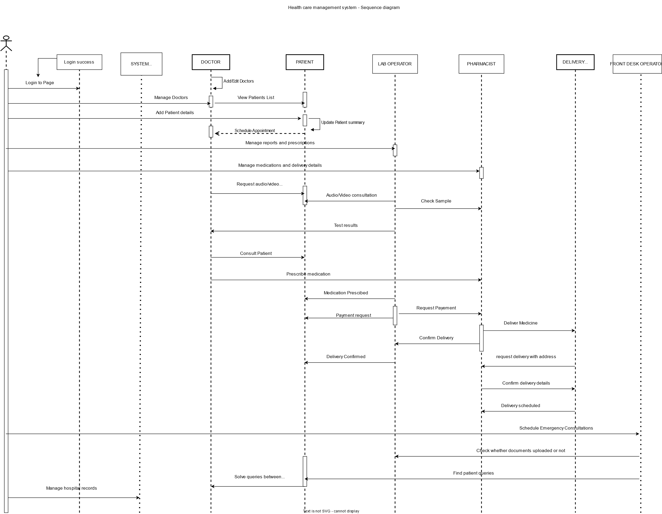

Fig 3 Sequence diagram

Data base design : [view the diagram link](https://drive.google.com/file/d/1LUgjl7EmzLGPuAt1T1kUndDmWRd-Lzgb/view?usp=sharing)

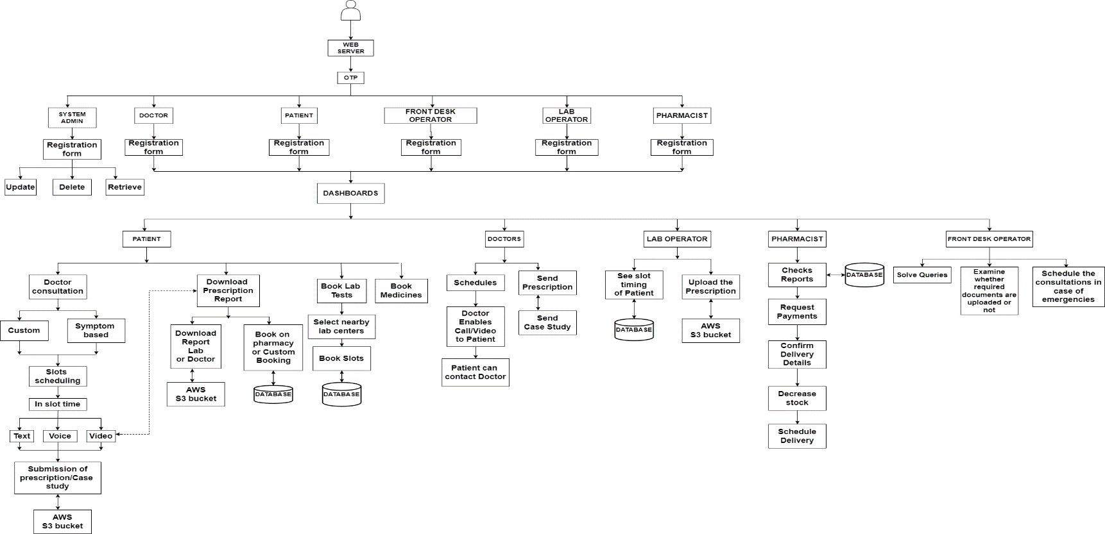**3.3 Data Flow Diagram**

Fig 4**.** Data flow diagram

Flow Diagram Design : [view this diagram online by clicking here](https://drive.google.com/file/d/10ev484pkaGnaFlk1AD-iakM3CmhcLp9m/view?usp=sharing)

**3.4 Data Base Design**

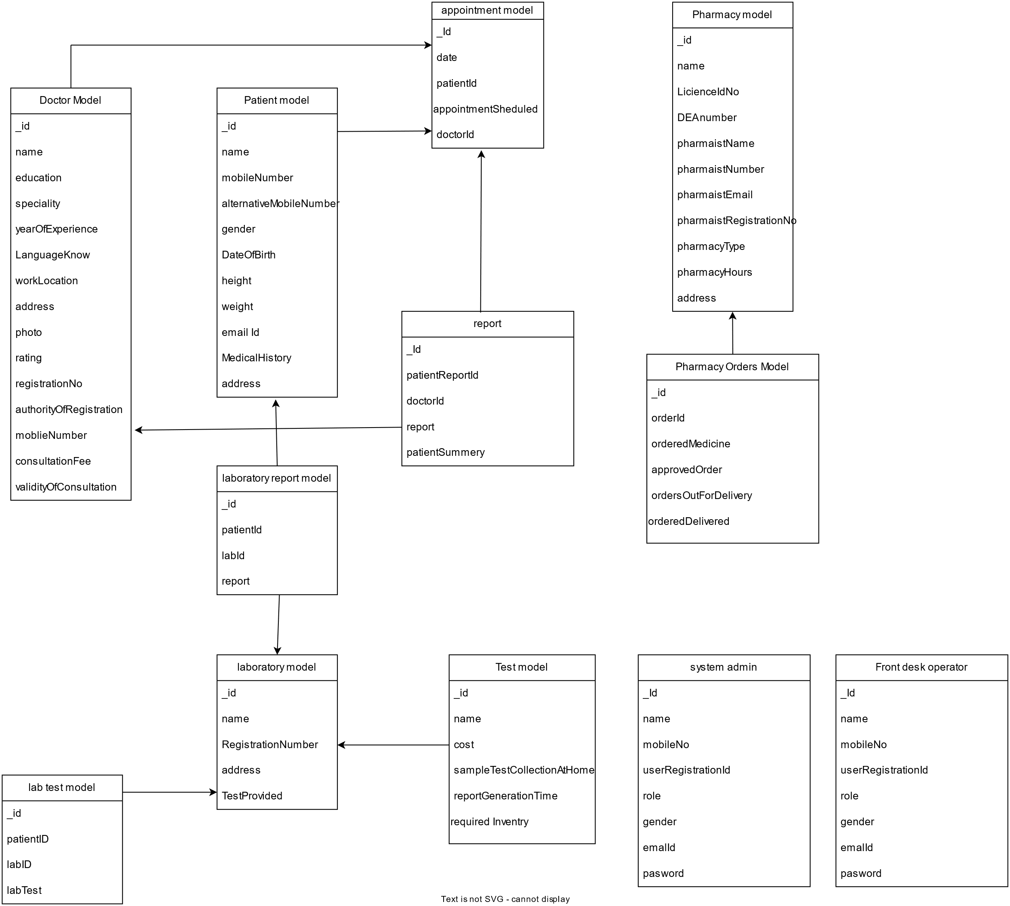

Fig 5 : Data Base Design

Data base design : [View this diagram online by clicking here](https://tinyurl.com/avanteldbv2)